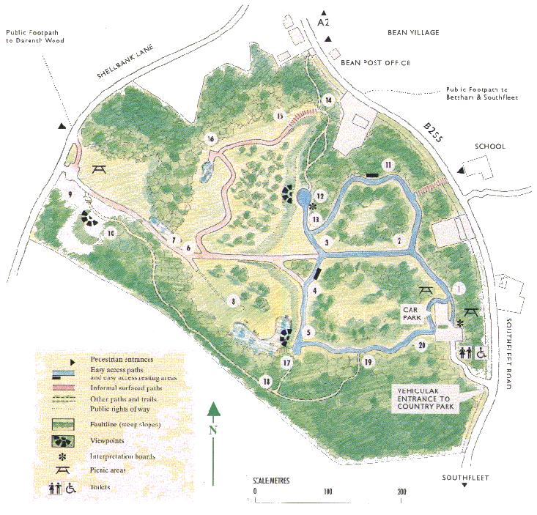
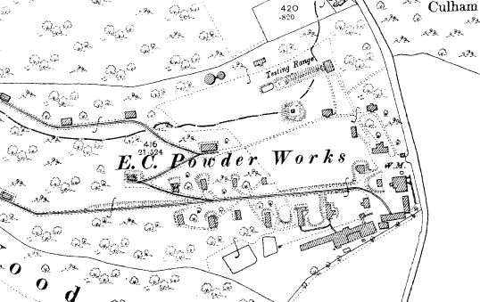
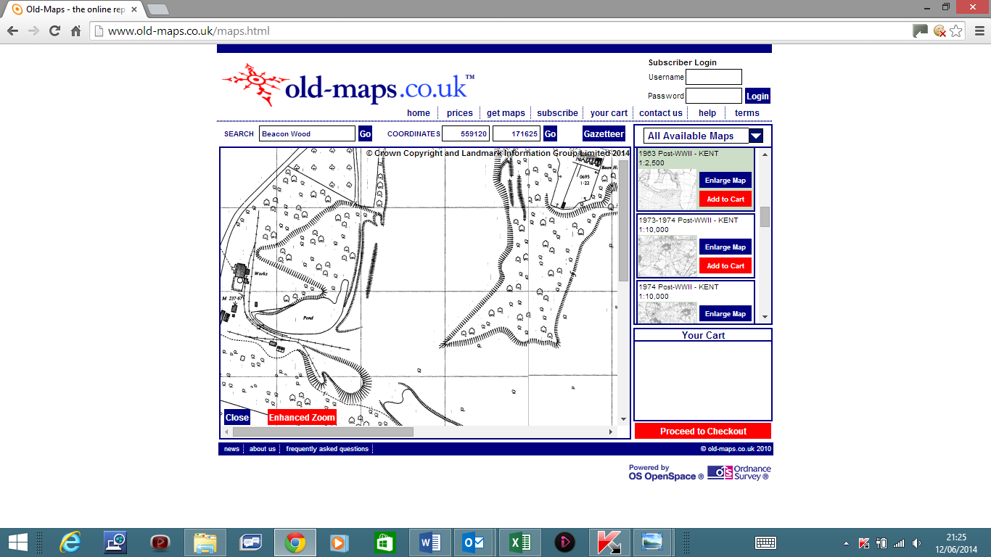
Clay Pit Buildings and Rail Tracks from 1963 OS Map
Powder Works Buildings, Tramways and Testing Range from 1909 OS Map
BEACON WOOD COUNTRY PARKMap from Visitors Guide January 1994
BEACON WOOD COUNTRY PARK
Map from Visitors Guide overlaid to show 1960’s Clay Pit and 1900’s Powder Works Industrial Heritage

http://www.users.waitrose.com/~beanra/history/beacon_wood-visitor_guide+powder%20works+clay_pit.docx

